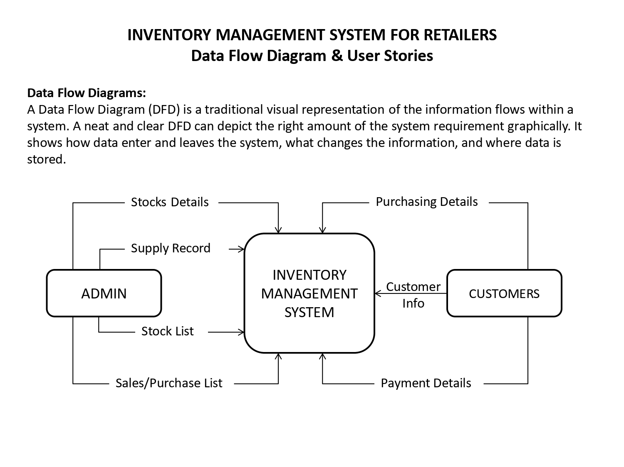

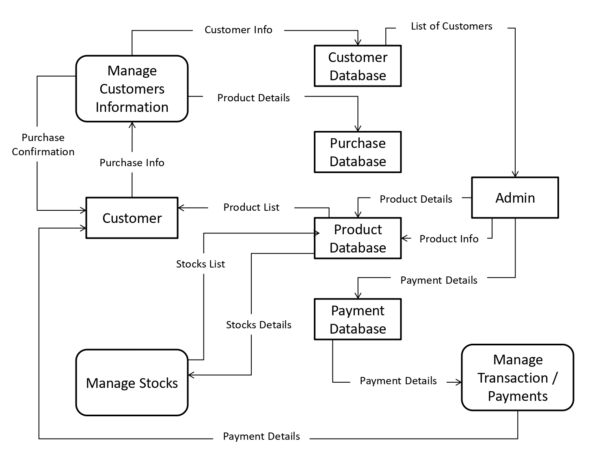

**User Stories:**

|  |  |  |  |  |  |  |
| --- | --- | --- | --- | --- | --- | --- |
| **User Type** | **Functional**  **Requirement (Epic)** | **User Story Number** | **User Story / Task** | **Acceptance criteria** | **Priority** | **Release** |
| Customer (Mobile user) | Registration | USN-1 | As a user, I can register for the application by entering my email, password, and confirming my password. | I can access my account / dashboard | High | Sprint-1 |
|  |  | USN-2 | As a user, I will receive confirmation email once I have registered for the application | I can receive confirmation email & click confirm | High | Sprint-1 |
|  |  | USN-3 | As a user, I can register for the application through Face book | I can register & access the dashboard with Face book Login | Low | Sprint-2 |
|  |  | USN-4 | As a user, I can register for the application through Gmail | I can register and access the dashboard with Gmail login | Medium | Sprint-1 |
|  | Login | USN-5 | As a user, I can log into the application by entering email & password | I can register and access the dashboard with email and password | High | Sprint-1 |
|  | Dashboard | USN-6 | As a user, I can view the stock availability status | I can view the stock availability status | High | Sprint-2 |
|  |  | USN-7 | As a user, I can view the orders status | I can view the order status | Medium | Sprint-3 |
|  |  | USN-8 | As a user, I can view the shipping tracking status | I can view the shipping tracking status | Medium | Sprint-4 |
|  | Alerts | USN-9 | As a user, I should receive alerts on stock availability if it drops below the set threshold | I should receive prompt alerts on stock availability if it drops below the set threshold | Medium | Sprint-4 |
| Customer (Web user) | Registration | USN-10 | As a user, I can register for the application by entering my email, password, and confirming my password. | I can access my account / dashboard | High | Sprint-1 |
|  |  | USN-11 | As a user, I will receive confirmation email once I have registered for the application | I can receive confirmation email & click confirm | High | Sprint-1 |
|  |  | USN-12 | As a user, I can register for the application through Face book | I can register & access the dashboard with Face book Login | Low | Sprint-2 |
|  |  | USN-13 | As a user, I can register for the application through Gmail | I can register and access the dashboard with Gmail login | Medium | Sprint-1 |
|  | Login | USN-14 | As a user, I can log into the application by entering email & password | I can register and access the dashboard with email and password | High | Sprint-1 |
|  | Dashboard | USN-15 | As a user, I can view the stock availability status | I can view the stock availability status | High | Sprint-2 |
|  |  | USN-16 | As a user, I can view the orders status | I can view the order status | Medium | Sprint-3 |
|  |  | USN-17 | As a user, I can view the shipping tracking status | I can view the shipping tracking status | Medium | Sprint-4 |
| Customer Care Executive |  | USN-18 | As a customer care executive, I can view the complaints on chat box | I can view the complaints on chat box | Medium | Sprint-4 |
|  |  | USN-19 | As a customer, I should be able solve and reply for the customers queries | I can reply to customer queries in the chat thread | Low | Sprint-4 |
|  |  | USN-20 | As a customer, I can close the complaint after assisting | I can close the complaint after assisting | Low | Sprint-4 |
| Administrator |  | USN-21 | As a Administrator, I would take care of registrations and maintenance of accounts | I can take care of registrations and maintenance of accounts | High | Sprint-3 |
|  |  | USN-22 | As a Administrator, I Would resolve issues on Access | I can resolve issues in Access | High | Sprint-2 |